**5 Macam Query Join, Left Join, dan Right Join**

1. SELECT nama_obat, harga, obat.id_jenisobat, jenis_obat.jenis_obat

FROM `obat`

JOIN jenis_obat ON obat.id_jenisobat = jenis_obat.id

ORDER BY id_jenisobat ASC

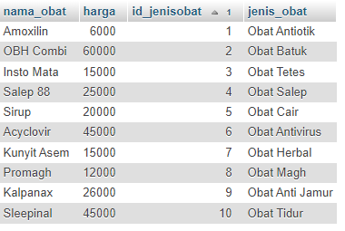

1. SELECT jumlah_obat, pajak, total_bayar, nama_pelanggan, jenis_kelamin, pelanggan.alamat

FROM `transaksi`

RIGHT JOIN pelanggan ON transaksi.id_pelanggan = pelanggan.id

ORDER BY id_pelanggan ASC

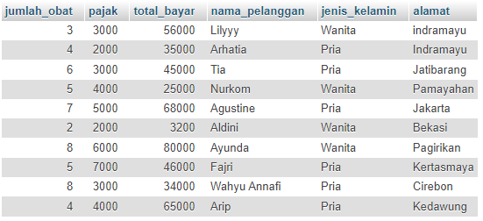

1. SELECT jumlah_obat, pajak, total_bayar, nama_obat, harga

FROM `transaksi`

LEFT JOIN obat ON transaksi.id_obat = obat.id

WHERE pajak LIKE '%3000%'

ORDER BY id_obat ASC

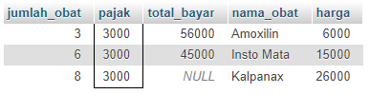

1. SELECT distributor.nama, distributor.alamat, distributor.kota, distributor.no_telp,

penjual.nama, penjual.alamat, penjual.kota, penjual.no_telp

FROM `distributor`

JOIN penjual ON distributor.penjual_id = penjual.id

WHERE distributor.no_telp is NULL

ORDER BY penjual_id ASC 

1. SELECT * FROM distributor

JOIN penjual

ON distributor.penjual_id =penjual.id;

